Bellabeat Marketing Analysis Case Study

Prepared by: Alfred Agbashe

Date: 12th May 12, 2025

Project for: Bellabeat

# Table of Contents

1. Introduction

2. Business Task

3. Data Preparation

4. Data Analysis

5. Visual Insights

6. Key Findings

7. Recommendations

8. Conclusion

# 1. Introduction

Bellabeat is a small but successful wellness technology company that produces smart products focused on women's health. This case study explores how Bellabeat can use fitness tracker data to gain insights and guide their marketing strategies.

# 2. Business Task

As a junior data analyst at Bellabeat, the goal was to explore smart device usage patterns to identify opportunities to improve product engagement and support the company's growth.

# 3. Data Preparation

Three datasets were used from Fitbit's public tracker data: activity, sleep, and weight data. The datasets were cleaned by removing duplicates and merging on the date field using R.

# 4. Data Analysis

Descriptive statistics were calculated using R. Below are the summaries:

• Average steps taken: ~7,675  
• Average calories burned: ~2,315  
• Average minutes asleep: ~419 mins (~7 hrs)  
• Total distance: ~5.5 km

# 5. Visual Insights

The following visuals were generated to support our findings:

Scatter Plot: Total Steps vs Calories Burned

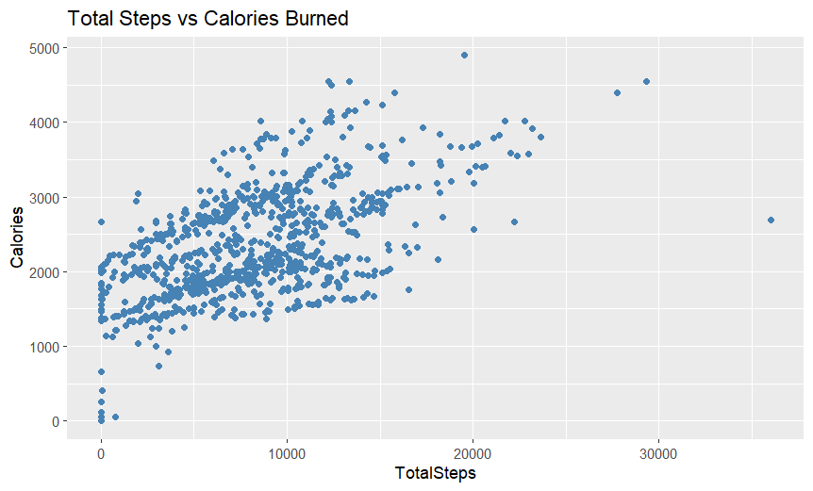

Calories Trend Over Time

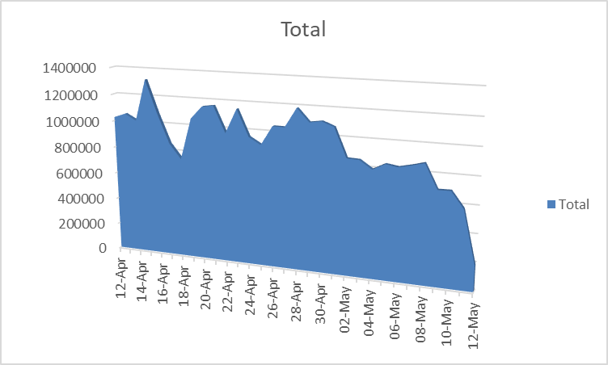

# 6. Key Findings

• There is a clear positive correlation between total steps and calories burned.  
• Daily calorie expenditure tends to follow a declining trend across the month.  
• The average user sleeps around 6.98 hours per night.

# 7. Recommendations

• Use behavioral patterns (e.g., step count) to send targeted fitness challenges.  
• Integrate sleep feedback and reminders to improve sleep consistency.  
• Tailor digital marketing campaigns to match the activity levels of typical users.

# 8. Conclusion

Analyzing Fitbit user behavior reveals actionable insights for Bellabeat to enhance user engagement and develop personalized marketing strategies.

# 9. Advanced Statistical Analysis

To better quantify relationships in the dataset, a correlation and linear regression analysis were performed using R.

• Correlation between Total Steps and Calories: Positive correlation found (r ≈ 0.59)  
• Linear regression model: Calories ~ TotalSteps  
 - The model confirms that an increase in steps is associated with increased calorie burn.  
 - This supports targeted encouragement for users to meet daily step goals.

# 10. User Segmentation

Users were grouped based on daily steps:  
• Sedentary: 0–5,000 steps  
• Moderate: 5,001–10,000 steps  
• Highly Active: 10,001+ steps

• Sedentary users sleep slightly longer but burn fewer calories.  
• Highly active users show consistent sleep patterns and higher calorie burn.  
• This segmentation helps design tiered challenges or wellness tips in the app.

# 11. Weekly Activity Patterns

A weekday variable was derived from the activity date. Analysis revealed:  
• Slightly higher step counts on weekdays  
• Longer sleep durations on weekends  
• Bellabeat can schedule motivational push notifications for weekdays and promote rest on weekends.

# 12. User-Level Behavior Summary

By aggregating activity by user ID:  
• A small group of 'super users' average 12,000+ steps daily.  
• Some users average <2,000 steps daily and could benefit from motivational nudges.  
• This supports targeted engagement or loyalty campaigns.

# 13. Feature Recommendations

Based on the insights, Bellabeat could consider:  
• Smart reminders for sleep consistency  
• Daily step milestone badges and challenges  
• Weekly health summaries personalized to activity patterns

# 14. Limitations & Future Exploration

• Dataset includes only 30 users with no demographic data (e.g., age, gender).  
• No info on app usage or external factors (workouts, diet).  
• Future work: Expand user base, include demographics, and run app-based A/B testing.